Data-Driven Approaches to Crime and Traffic Safety:
Model Implementation Policy
Jerrod S. Hart
Eastern Michigan University

IMPLEMENTATION GUIDELINES: DATA-DRIVEN APPROACHES TO CRIME AND TRAFFIC SAFETY (DDACTS)
Effective April 18, 2013

PURPOSE
In order to reduce crime and promote traffic safety, the department is implementing a proactive, place-based policing model designed to reduce crime and traffic crashes within our community.

SCOPE
This policy applies to all sworn and non-sworn personnel involved in the enforcement, collection, investigation and reporting of crime and traffic crashes.

POLICY

Data-Driven Approaches to Crime and Traffic Safety (DDACTS) is a law enforcement operational model developed by the National Highway Traffic Safety Administration (NHTSA) and agencies within the Department of Justice (DOJ). DDACTS integrates location-based crime and traffic data to establish efficient deployment strategies for law enforcement resources (U.S. Government, 2009).
Through the use of geo-mapping technology, crime and traffic crash locations are plotted on a map using temporal and spatial analysis to identify “hot spots”. Once identified, the area is saturated with highly visible traffic enforcement strategies in order to reduce social harms associated with incidences of crime, traffic crashes and traffic violations. The concept draws upon the knowledge that crimes often involve the use of a motor vehicle and the offender will recognize an increased likelihood of apprehension due to a highly visible police presence (U.S. Government, 2009).
DDACTS relies on the following seven (7) guiding principles (U.S. Government, 2009):

Partner and Stakeholder Participation

Data Collection

Data Analysis

Strategic Operations

Information Sharing and Outreach

Monitoring, Evaluation, and Adjustments

Outcomes

PROCEDURE

Implementation Team
In order to generate comprehensive buy-in throughout the agency, the administration shall create an implementation team. Team members should possess excellent interpersonal skills and represent various disciplines within the department. Members shall include the agencies Michigan Incident Crime Reporting (MICR) designee or Crime Analyst, a Command Officer, Patrol Officer, Investigator and Dispatcher (Seals, 2013; U.S. Government, 2009).

Duties of the implementation team include:

Review the departments Records Management System (RMS), MICR and eCrash verification procedures and available Geographic Information System (GIS) technology for familiarization (Seals, 2013).

As a team, attend a DDACTS workshop presented by the National Highway Traffic Safety Administration (NHTSA).

Make recommendations to enhance/improve the department’s MICR and eCrash verification processes to ensure proper data entry based on DDACTS analysis requirements.

Design a DDACTS Strategic Operations Plan template to include a map with temporal and spatial analysis.

Identify reporting procedures for assigned personnel to document DDACTS activity.

Develop a DDACTS role call training presentation (Seals, 2013).

Partner/Stakeholder Participation and Information Sharing
Key to crime reduction and improved traffic safety are partnerships with local stakeholders. Efforts to inform stakeholders of the DDACTS initiative, obtain feedback and encourage participation shall include the following:

Chief Law Enforcement Officer or his/her designee:

Coordinate a press release with local media outlets prior to DDACTS implementation and conduct follow up interviews as necessary.

Inform elected officials of the initiative prior to implementation.

Partner with surrounding law enforcement executives to solicit additional assistance with highly visible patrol efforts.

Explore the feasibility of developing a DDACTS reporting “App” to keep the community informed of outcomes and encourage reporting of incidents.

Include a monthly DDACTS reporting summary on the department’s website or local unit of government’s dashboard.

Include a DDACTS summary report in the annual budget message.

Patrol Division Lieutenants:

Assign staff to attend neighborhood homeowner association meetings in their district to share the initiative and elicit feedback and buy-in prior to implementation.

Ensure officers include DDACTS reporting information in their monthly homeowner’s association contacts for inclusion in the monthly report.

Sergeant – Traffic Safety Committee:

Prior to implementation, ensure all members of the committee are familiar with the initiative.

Implement a DDACTS report into the quarterly meeting.

Include committee feedback in the summary report.

Sergeant – Investigations:

Ensure investigators share DDACTS initiative with crime victims.

Share DDACTS initiative with surrounding investigators at monthly detectives meetings.

Incorporate a DDACTS module into the Citizens Police Academy.

Data Collection

Internal Source

Proper data entry is essential to the department’s crime and traffic crash reporting systems. All personnel authorized to complete crime and crash reports shall be trained in the department’s RMS, crash and citation programs to minimize errors.

Common reporting errors include; double reporting, improper location and improper or omitted time of occurrence or timeframe (Seals, 2013).

The department shall have a clear report writing policy outlining required information and the process for submitting and approving all crime, crash and traffic citations.

The implementation team shall emphasize the importance of correct data entry in the roll call training presentation.

External Source

According to Blough (2013) common external sources of data include; U.S. Census, Southeast Michigan Council of Governments (SEMCOG), Federal Bureau of Investigation (FBI) Uniform Crime Report (UCR) and National Highway Traffic Safety Administration (NHTSA).

A clear understanding of how the data was collected is essential before proper analysis (Blough, 2013).

It will be the crime analyst’s responsibility to review all external data sources for proper analysis (Seals, 2013; Blough, 2013).

Data Analysis
The ability to merge various crime, traffic crash and traffic related data with GIS mapping technology is essential to identifying problem areas. The implementation team is responsible for reviewing the data collection processes and making any recommendations for improvements based on the following:

According to the U.S. Government (2009) proper analysis requires a minimum of three (3) years of crime and traffic crash data to identify problem areas with five (5) years of data being optimal (Seals, 2013).

To further identify problem areas, the same month should be compared over the analysis period in addition to year to date analysis. This will allow for proper causation analysis in seasonal crime and traffic issues, economic conditions and environmental factors (Seals, 2013).

Data analysis can be accomplished through an in-house analyst or outsourced through a web based vendor.

In-House Analyst

Shall be properly trained in analysis, RMS and GIS programs (Blough, 2013).

Determine the desired output from the analyst and how many are needed (International Association of Crime Analysts, 2013)– See Appendix A.

Requires specialized computer equipment – See Appendix B.

If a new position, seek job postings from agencies with crime analysts - See Appendix C.

An equally trained backup should be designated to accommodate extended absences (Blough, 2013).

Required to know source and collection methods for all data sources (Seals, 2013).

Responsible for weekly and monthly reporting of DDACTS performance measurements and updating reporting methods.

Produce Strategic Operations Plan for command officers.

Outsourcing

Cloud based programs allow for remote analysis of data by private companies for a nominal fee.

Information from the department’s RMS system is uploaded into the system on a predetermined schedule.

The implementation team should conduct a thorough review of all vendors and recommend a vendor based on their DDACTS training and RMS requirements (Seals, 2013).

Will require training for designated personnel to develop Strategic Operations Plan from the data.

Strategic Operations
According to a 2008 Police Executive Research Forum (PERF) study on violent crime in America, most police departments identified directed patrols and increased traffic enforcement in “hot spots” as a primary response to criminal activity. Of the agencies surveyed (N = 176), 70% relied on monthly statistics and reports to identify hot spots and 92% measured success by a reduction in crime.
The strategic operations plan identifies “hot spots” for temporal and spatially focused patrols. It is developed by the implementation team to assist command staff in the allocation of resources based on unbiased data (U.S. Government, 2009). According to McLean & Worden (2009), the strategic operations plan should include temporal and spatially focused patrols based on the following criteria:

They are proactive and aggressive

Officers use their uncommitted time to engage in purposeful activity

Officers have specific instructions directing their activity.

The instructions are based on thorough analyses of crime and crash data.

In order to maximize the effectiveness of the DDACTS model, Uniform Patrol Lieutenants and Sergeants are required to take a strong leadership role (U.S. Government, 2009) to:

Deliver the roll call presentation developed by the implementation team to all staff under their command (Mutchler, 2013).

Utilize the DDACTS Strategic Operations plan to deploy highly visible traffic enforcement into the problem area.

Utilize speed signs, decoy cars and other means to impact crime and traffic safety.

Hold assigned staff accountable through spot checks of problem areas and a review of DDACTS related activity.

Request additional resources through the chain of command as needed.

Maintain appropriate staffing levels to handle normal workflow and saturate problem areas (U.S. Government, 2009).

Review all reports for correct data entry.

Support the initiative during staff and community interactions.

Monitoring, Evaluation and Adjustments
In order to review the impact of the Strategic Operations Plan, a regular meeting schedule shall be developed prior to implementation. The meeting should be scheduled on the same day each week and may be incorporated into an existing staff or CompStat meeting and shall include:

Administrators, command staff, police officers, crime analyst/MICR designee, dispatch staff and investigators.

A complete review of all crime and traffic crash data.

Feedback from staff, partners or stakeholders (U.S. Government, 2009).

An opportunity to adjust countermeasures (U.S. Government, 2009).

A review of mapping techniques, data analysis, training and equipment needs (U.S. Government, 2009).

Outcomes
Once a baseline of crime and traffic crash data have been established through analysis, the implementation team should establish realistic reduction goals for each category. The goals shall be shared internally and externally through CompStat meetings, DDACTS App, Community Dashboard or other methods approved by the Chief of Police or his / her designee.
REFERENCES
Blough, C. (2013, March 7). Interview by J.S. Hart [Personal Interview]. Interview with City of Novi geographic information system manager.
International Association of Crime Analysts. (2013). Implementing crime analysis. Retrieved from http://www.iaca.net/dc_implementation.asp
McLean, S. J., & Worden, R. E. National Highway Transportation Safety Administration, (2009). Ddacts in theory and practice. Retrieved from John F. Finn Institute website: www.nhtsa.gov/staticfiles/nti/ddacts/DDACTS_Theory_Practice-092009.pdf
Mutchler, T. L. (2013, April 04). Interview by J.S. Hart [Personal Interview]. Ddacts implementation: Canton public safety.
Police Executive Research Forum. (2008, May). Critical issues in policing series: Violent crime in america. Retrieved from http://policeforum.org/library/critical-issues-in-policing-series/HotSpots_v4.pdf
Seals, D. (2013, February 13). Intelligence led policing yardsticks: Department wide roll out. Retrieved from http://www.publicengines.com/blog/2013/02/13/intelligence-led-policing-yardsticks-department-wide-roll-out/
Seals, D. J. (2013, March 11). Interview by J.S. Hart [Personal Interview]. Intelligence led policing: Ddacts.
U.S. Government. U.S. Department of Transportation , National Highway Traffic Safety Administration. (2009). Data-driven approaches to crime and traffic safety: Operational guidelines. Retrieved from U.S. Department of Transportation website: http://www.nhtsa.gov/ddacts

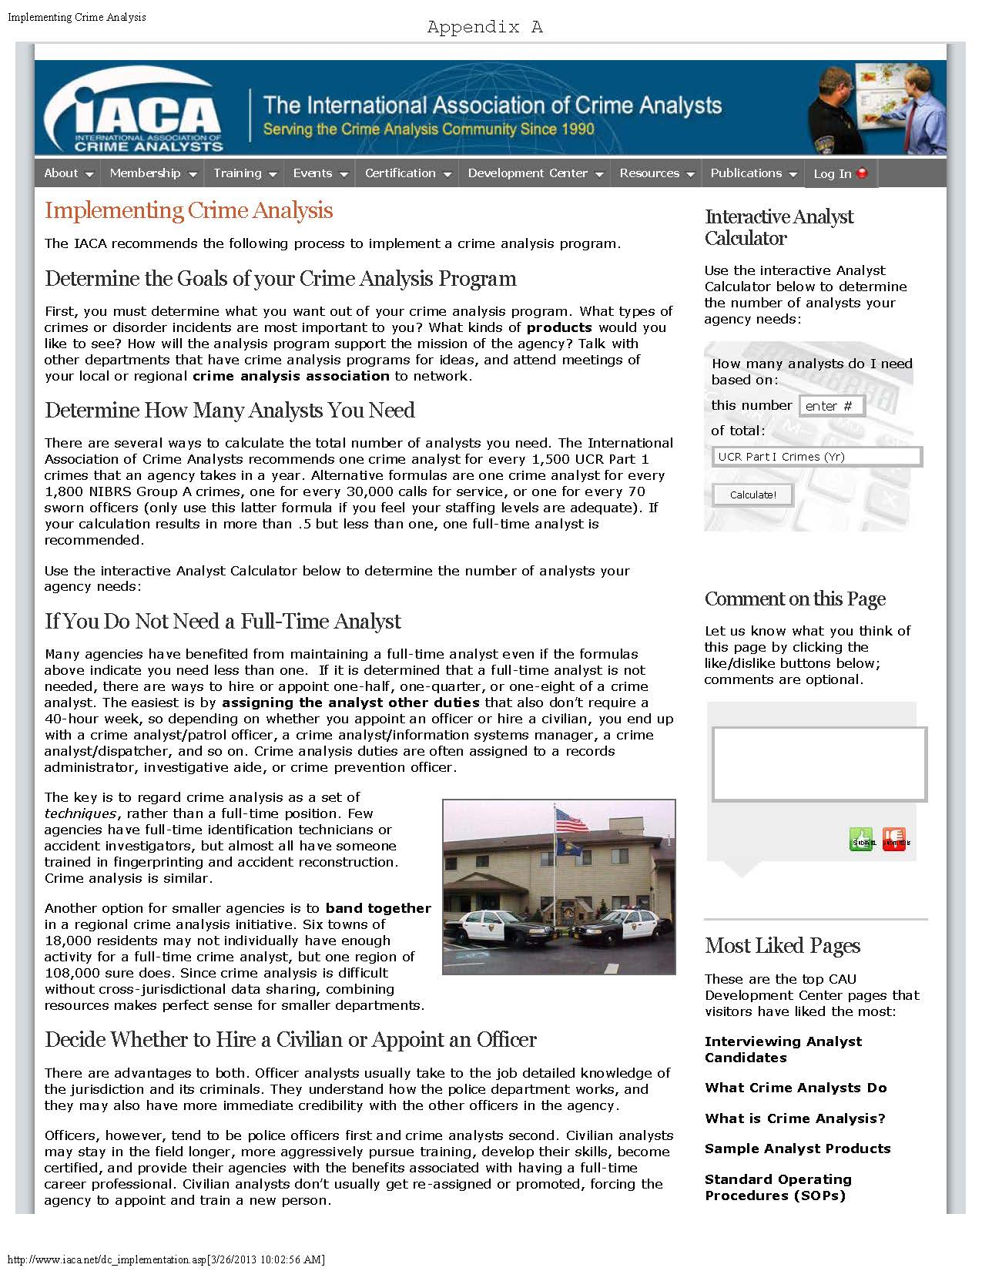
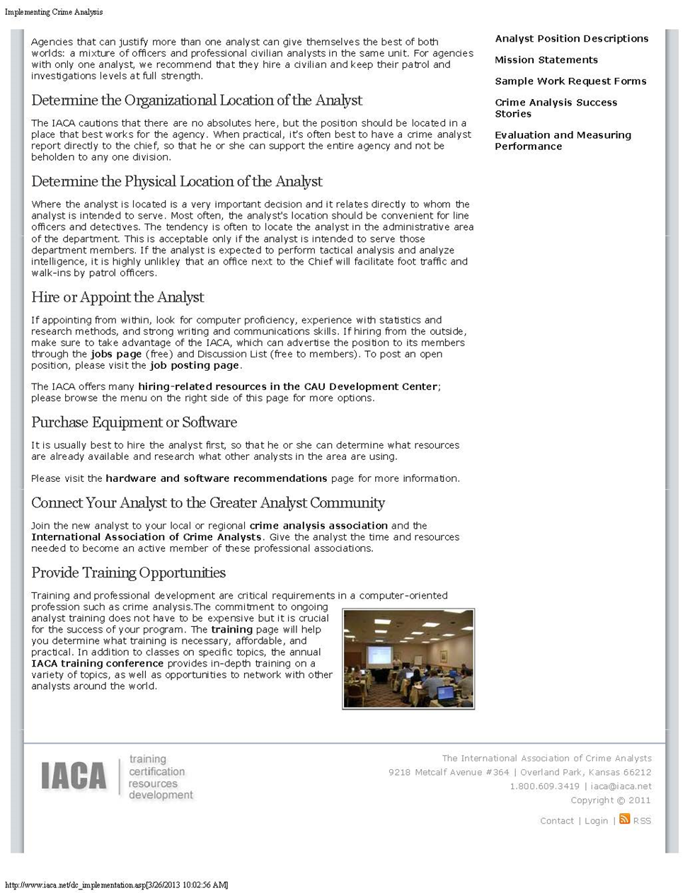
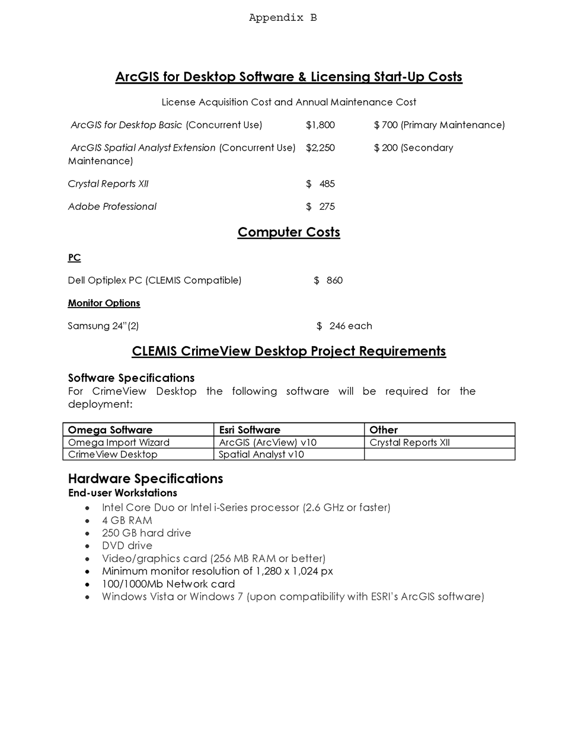
Appendix C
Crime Analyst / Records Clerk – Full Time Position
The City of Novi, Michigan invites your interest for a full-time position of Crime Analyst / Records Clerk to serve in the Public Safety Records Section. The successful candidate will; collect, categorize and analyze data pertaining to criminal activity, prepare and disseminate reports using various illustrative and statistical methods and make recommendations pertaining to the existing and anticipated criminal activity to internal departments. This position also entails general office, clerical, typing and records keeping duties and interaction with the public.
Duties include analyzing, interpreting and making deductions from various data sources such as crime data, police reports, computer aided dispatch information and various databases and sources to identify current and future crime patterns or trends. Provide accurate, timely and relevant analysis of crime patterns that aid the police department in the reduction of crime. Verify the accuracy and completeness of records, forms, documents and attachments according to detailed procedures or by comparison with original sources. Perform clerical work as required such as alarm notification, billing, court services or other assigned duties.
Qualifications include a Bachelor’s degree with course work in criminal justice, social sciences, computer science or related field preferred or, an equivalent combination of education and experience sufficient to successfully perform the essential duties of the job. Possess, or be able to attain, or demonstrate skills and abilities equivalent to the Microsoft Office Specialist certification, specifically in Excel and Power Point. Ability to achieve proficiency in various information system platforms including the departments records management system (CLEAR). Successful completion of IACA Essential Skills I and II programs within one year of employment. Candidates who are detail-oriented and are effective oral and written communicators will be favorably considered.
Starting salary is $31,939 with a comprehensive benefits package. Apply promptly with cover letter, resume and completed City application to Human Resources, City of Novi, 45175 West Ten Mile Road, Novi, MI 48375 or email Robin Kummer at rkummer@cityofnovi.org. Posting closes on XXXX XX. EOE.
Appendix D
Glossary of Selected Terms
Application (App) - Any program designed to perform a specific function directly for the user. http://searchsoftwarequality.techtarget.com/definition/application-program
Dashboard - a visual display of the most important information needed to achieve one or more objectives; consolidated and arranged on a single screen so the information can be monitored at a glance. http://computer.yourdictionary.com/dashboard
Data-Driven Approach to Crime and Traffic Safety (DDACTS) –Business model that utilizes highly visible traffic enforcement strategies to fight crime and reduce crashes at the local level by using geo-mapping techniques to identify hot spot areas. http://www.nhtsa.gov/ddacts
eCrash – Electronic traffic crash reporting system.
Geographic Information System (GIS) – a computer system capable of capturing, storing, analyzing, and displaying geographically referenced information. http://egsc.usgs.gov/isb/pubs/gis_poster/
Geo-Mapping – The location-based tracking of an event or incident, most often using some type of computerized geographic information system. http://www.nhtsa.gov/ddacts\
Hot Spot - Crime and traffic data analysis and evaluation dedicated to locating concentrations of crime, crash and traffic safety problems. http://www.nhtsa.gov/ddacts
Location-based policing - An approach to crime and crash reduction that focuses on places where crime and crashes occur, as a means for deploying resources. http://www.nhtsa.gov/ddacts
Michigan Incident Crime Reporting (MICR) – Michigan’s incident-based crime reporting system in which data is collected on each single crime occurrence then forwarded to the Federal Bureau of Investigation. http://www.micrstats.state.mi.us/MICR/Home.aspx
Record Management System (RMS) – A computer based program designed to properly record, store, and retrieve departmental and criminal records with automated MICR submission. http://www.oakgov.com/clemis/Documents/FACT_MASTER.pdf
Social Harm – An approach to community issues that should encompass physical harm, economic harm and cultural safety. http://www.nhtsa.gov/ddacts
Spatial analysis – Examination of what happens where, and makes use of geographic information that links features and phenomena to their locations. http://www.spatial-analyst.com/?page_id=7

Temporal Analysis – Examination of when something occurs over long, mid and short term in order to develop patterns. http://www.crimeanalysis.umd.edu/crimeanalysis.php

Traffic Safety Committee – A Multi-disciplined team of individuals that meet quarterly to discuss traffic safety related issues. Comprised of a police sergeant, traffic engineers from the city and county road commission, Traffic Improvement Association and school district representatives.

